CONTENTS

1. DESCRIPTION………………………………………………... 2

1. OBJECTIVE ………………………………………………..… 2

1. THE FEASIBILITY STUDY ……………………………….... 3

1. SOFTWARE REQUIREMENT SPECIFICATION……..…… 7

1. ANALYSIS PHASE………………………………………….. 9

1. BUILDING PROTOTYPES …………………………..…...…...9

1. SOFTWARE DESIGN PHASE………………………….….... 13

1. TESTING PHASE…………………….………………….….… 17

1. IMPLEMENTATION………………………………………… 19

1. MAINTENANCE & SUPPORT…………………………….... 21

**CIT Departmental Connect: A Blockchain-Enabled Mobile Application for Enhanced Academic Communication**

**DESCRIPTION:**

**"CIT Departmental Connect"** is an innovative mobile application tailored for the Coimbatore Institute of Technology (CIT) community, aiming to revolutionize communication and information sharing within the institution. With a centralized platform accessible to students, faculty, and department heads, the app provides comprehensive details on CIT departments, faculty members, and upcoming events.

It boasts blockchain integration for top-tier data security, ensuring information integrity. Secure messaging options allow direct communication with department heads via WhatsApp or Gmail, while a dedicated section for notes and reminders facilitates important updates. Powered by Firebase, the app offers robust user authentication and real-time database connectivity for seamless performance. With an intuitive interface and focus on user needs, "CIT Departmental Connect" enhances efficiency and fosters a more connected academic environment at CIT.

**OBJECTIVE:**

The primary goal of CIT Departmental Connect is to enhance communication and collaboration within the Coimbatore Institute of Technology (CIT) community. Through a centralized platform for departmental information and reminders, the app aims to boost engagement, productivity, and satisfaction among students and faculty. Addressing the issue of limited information access, the app offers detailed insights into CIT departments, facilitating easier access to necessary information and supporting academic and administrative tasks for more efficient institutional operation.

Another critical objective is bridging the communication gap between users and department heads. Integrated messaging features enable direct and timely communication, fostering a more collaborative and responsive environment. Users can also connect with department heads via WhatsApp and Gmail directly from the app, enhancing convenience and efficiency in communication.

Security and authentication are paramount. Firebase Authentication ensures secure access and protects user data, while blockchain technology enhances data security and integrity, safeguarding sensitive information. Smart contract integration streamlines administrative processes, reducing paperwork, manual interventions, and errors, leading to better resource utilization and operational efficiency. Ultimately, CIT Departmental Connect empowers the CIT academic community by providing efficient communication channels, enhancing data security, and fostering a collaborative environment conducive to academic success.

**Feasibility Study for "CIT Departmental Connect"**

**Scope of the Work:**

CIT Departmental Connect is intended to serve as a comprehensive communication platform for the Coimbatore Institute of Technology (CIT) community. The scope of the work includes:

**User Authentication and Security:** Implementing secure user authentication using Firebase Authentication to ensure that only authorized users have access to the app.

**Blockchain Integration:** Incorporating blockchain technology to ensure data integrity and security, making sure that all data and interactions are immutable and tamper-proof.

**Departmental Information Access:** Developing modules that provide detailed information about various CIT departments, including faculty profiles, course schedules, and contact information.

**Messaging System:** Integrating a messaging system that allows direct communication between students, faculty, and department heads via platforms like WhatsApp and Gmail.

**Notes and Reminders:** Creating a section where faculty members can post important notes, reminders, and announcements, ensuring these are stored immutably on the blockchain.

**User Interface Design:** Designing an intuitive and responsive user interface that ensures ease of navigation and a positive user experience.

**Administrative Process Automation:** Using smart contracts to streamline administrative processes, reduce paperwork, and minimize manual interventions.

**Existing Work:**

Currently, CIT may be using traditional methods such as email, notice boards, and physical meetings for communication and information dissemination. These methods have several drawbacks, including:

**Limited Accessibility:** Information may not be easily accessible to all users, especially those who are not on campus.

**Communication Delays:** Traditional methods can result in delays in communication and response times.

**Data Security Risks:** Without secure systems, sensitive information may be prone to unauthorized access or tampering.

**Manual Processes:** Many administrative processes may involve manual paperwork, leading to inefficiencies and errors.

**Proposed Work:**

The proposed mobile application aims to address these issues by:

**Centralizing Information Access:** Providing a single platform where all relevant departmental information is easily accessible.

**Enhancing Communication:** Facilitating instant communication through integrated messaging systems.

**Ensuring Data Security:** Leveraging blockchain technology to secure data and maintain its integrity.

**Automating Processes:** Using smart contracts to automate administrative tasks, reducing the need for manual intervention.

**Software Process Models:**

Several software process models can be considered for developing "CIT Departmental Connect." Here are a few approaches:

**Agile Model:**

Approach: Iterative and incremental development with continuous feedback from stakeholders.

Advantages: Flexibility to adapt to changing requirements, continuous delivery of functional components, and strong stakeholder involvement.

Suitability: Ideal for projects where requirements may evolve during the development process.

**Waterfall Model:**

Approach: Sequential development process where each phase must be completed before moving to the next.

Advantages: Clear structure and documentation, well-defined stages.

Suitability: Suitable for projects with well-defined requirements and minimal expected changes.

**DevOps Model:**

Approach: Combines software development (Dev) and IT operations (Ops) to shorten the development lifecycle and provide continuous delivery.

Advantages: Faster delivery of features, improved collaboration between development and operations, and continuous integration and deployment.

Suitability: Suitable for projects requiring frequent updates and deployments.

**Scrum Model:**

Approach: An Agile framework that uses sprints, typically 2-4 weeks long, with specific deliverables.

Advantages: Regular feedback, increased visibility, and adaptability to change.

Suitability: Well-suited for complex projects with evolving requirements and a need for frequent reassessment.

**Spiral Model:**

Approach: Combines iterative development with systematic aspects of the waterfall model; focuses on risk assessment.

Advantages: Focus on risk management, flexibility in design and development.

Suitability: Suitable for large, complex projects with high-risk factors.

**Recommended Approach:**

**Agile Model:**

Given the innovative nature of the "CIT Departmental Connect" project and the likelihood of evolving requirements based on stakeholder feedback, the Agile model is recommended. This approach allows for iterative development, frequent reassessment, and incorporation of feedback, ensuring the final product meets the needs of the CIT community effectively.

**Agile development will enable the project team to:**

* Develop and deliver functional components in short cycles.
* Regularly incorporate feedback from students, faculty, and department heads.
* Adapt to changing requirements and improve the app incrementally.

**Software Requirements Specification (SRS) for "CIT Departmental Connect"**

**Functional Requirements:**

The "CIT Departmental Connect" app will include several key functionalities. It will offer secure user authentication through Firebase, supporting roles such as students, faculty, and department heads. The integration of blockchain technology will ensure data is stored immutably, providing a tamper-proof environment. Users will have access to detailed departmental information, including faculty profiles, course schedules, and contact details. The app will facilitate direct messaging via WhatsApp and Gmail, and notify users of new messages and announcements. Faculty will be able to post notes and reminders, which will be stored on the blockchain for security. Additionally, the app will provide notifications for upcoming events and allow users to set custom reminders.

**Non-Functional Requirements:**

The app will prioritize performance, ensuring real-time updates and notifications, and handle up to 10,000 concurrent users without performance degradation. Security is paramount, with Firebase Authentication ensuring secure access and blockchain technology safeguarding data. Usability will be a key focus, with an intuitive and user-friendly interface designed for mobile devices. Reliability will be ensured with a 99.9% uptime guarantee and quick recovery from failures. The app will be scalable to support an increasing number of users and data, and maintainable with a modular architecture and clear documentation.

**Interface Requirements:**

The user interface will be responsive and suitable for mobile devices, offering easy navigation and a consistent layout. The app will integrate with Firebase for authentication and database management, WhatsApp and Gmail for messaging, and a blockchain API for data storage and retrieval. These integrations will ensure seamless functionality and secure communication within the app.

**Stakeholders' Requirements:**

The primary stakeholders include students, faculty, department heads, and administration. Students require easy access to departmental information and real-time notifications for events and messages. Faculty need a platform to securely post notes and reminders, and communicate efficiently with students and department heads. Department heads need an overview of departmental activities and secure communication tools. The administration seeks streamlined processes through smart contracts, secure storage of sensitive information, and efficient handling of user authentication and data access.

**Analysis Phase:**

The analysis phase involves understanding and detailing the requirements to create a clear roadmap for development. Requirement gathering will involve interviews and surveys with students, faculty, and department heads to identify their needs. Use case analysis will develop scenarios for user interactions, and system modeling will create diagrams to represent data flow and system architecture. Feasibility analysis will assess technical, economic, and operational aspects to ensure the project is viable. Finally, requirement validation will involve reviewing and confirming requirements with stakeholders and the development team, ensuring accuracy and feasibility. This comprehensive analysis will ensure that "CIT Departmental Connect" meets user needs, providing a secure, efficient, and user-friendly platform for enhanced academic communication at CIT.

**Building Prototypes:**

**User Interface (UI) Design and Navigation:**

The initial phase of building prototypes for "CIT Departmental Connect" will focus on developing an intuitive and responsive user interface (UI) that enhances user experience. The homepage dashboard will serve as the central hub, providing users with quick access to essential features such as departmental news, upcoming events, and quick links to frequently used sections like the department directory, messages, and personal reminders. A user-friendly navigation menu, accessible via a side drawer or bottom navigation bar, will allow users to switch seamlessly between different sections, including department profiles, a comprehensive faculty directory, the messaging platform, and notes/reminders. Each department will have a dedicated profile page containing an overview, detailed faculty profiles, contact information, and specific announcements.

**Secure Authentication and User Management:**

To ensure secure access and personalized user experiences, the app will employ robust authentication mechanisms and user management protocols. Firebase Authentication will be used to provide multiple login options, including email/password, Google Sign-In, and phone number verification, ensuring that only authorized members of the CIT community can access the app. The app will define distinct user roles with specific permissions: students will have access to view departmental information, events, personal reminders, and messaging faculty; faculty members will be able to post announcements, reminders, and respond to student messages; and department heads will have administrative access to manage departmental content, post updates, and communicate directly with both students and faculty. Role-based access control will ensure that users interact only with the functionalities relevant to their responsibilities, enhancing both security and usability.

**Blockchain Integration for Enhanced Security:**

To enhance data security, transparency, and trust within the app, blockchain technology will be integrated. All critical records, such as announcements, notes, and reminders, will be stored on a blockchain ledger, ensuring that once information is recorded, it cannot be altered or deleted, providing a secure and tamper-proof system. Messaging transactions will also be secured with blockchain encryption, ensuring that communications between students, faculty, and department heads are private and immutable. This integration will create a transparent and secure communication environment, enhancing trust among users.

**Real-Time Communication Features:**

The app will bridge communication gaps within the CIT community by incorporating real-time messaging and announcement features. Users will be able to send messages directly to department heads or faculty members through integrated platforms like WhatsApp or Gmail, facilitating immediate and convenient communication. Additionally, an in-app messaging system will be available for users who prefer to communicate within the app environment. Faculty members can post announcements and reminders, which will be broadcast to all relevant users and displayed on the dashboard and in the notes section, ensuring timely and effective communication.

**Prototype Development and Testing:**

The development process will involve creating and refining prototypes to test and perfect the app’s features. Early alpha prototypes will focus on core functionalities such as authentication, navigation, and basic departmental information display, undergoing internal testing to identify and resolve any issues. Subsequent beta prototypes will incorporate advanced features like blockchain integration, messaging, and user role management, and will undergo more extensive testing with a select group of stakeholders to gather feedback and make necessary adjustments. Throughout the development process, regular consultation with students, faculty, and department heads will be integral to refining the app. This iterative approach ensures that the final product meets the needs and expectations of its users, ultimately aiming to revolutionize communication and information access within the Coimbatore Institute of Technology community, fostering a more collaborative and supportive academic environment.

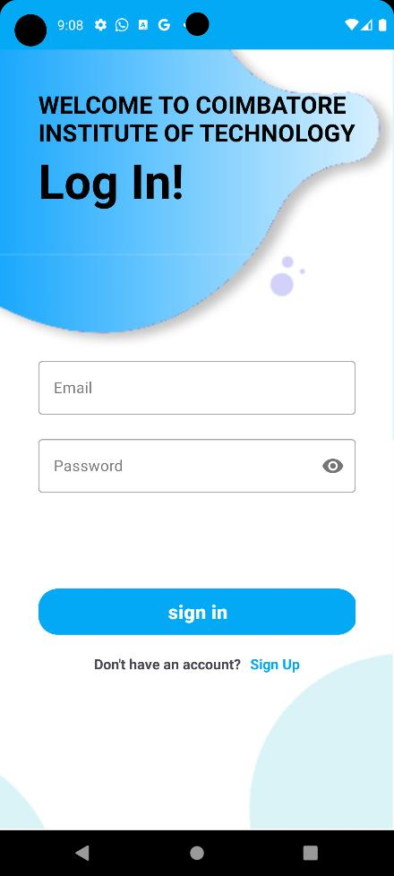 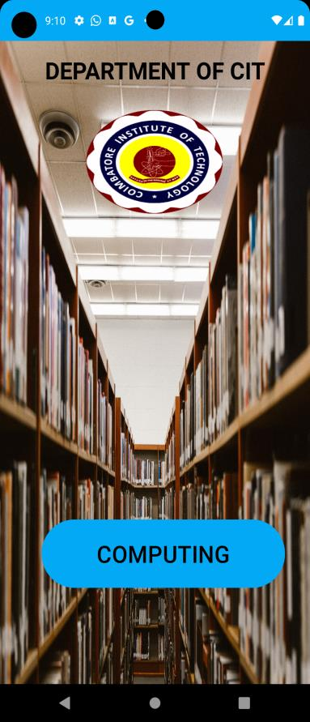 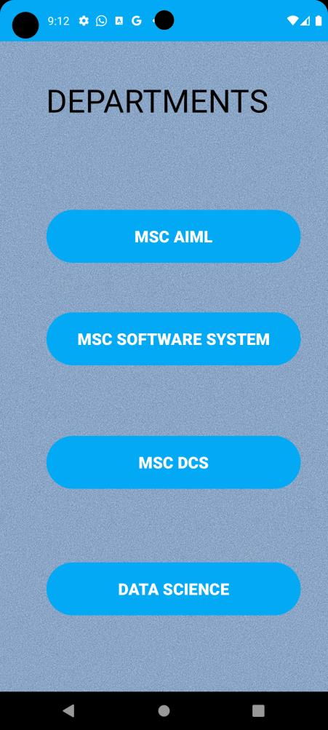

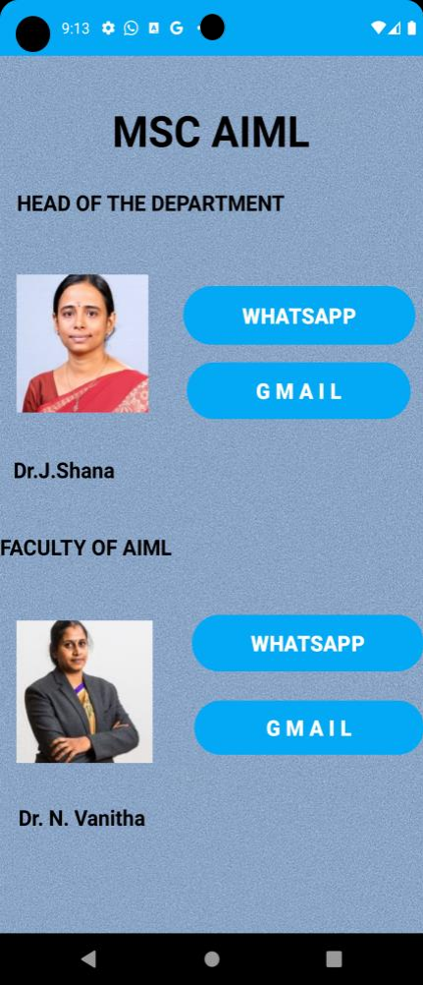 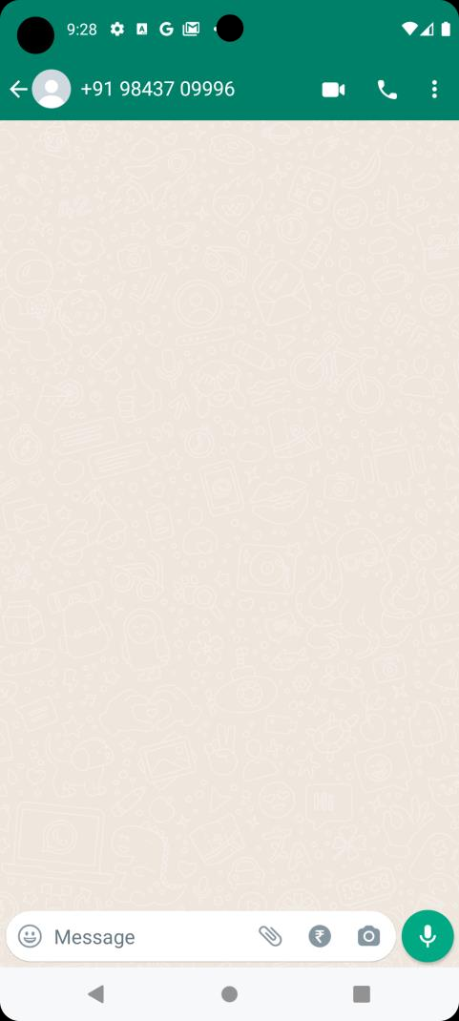 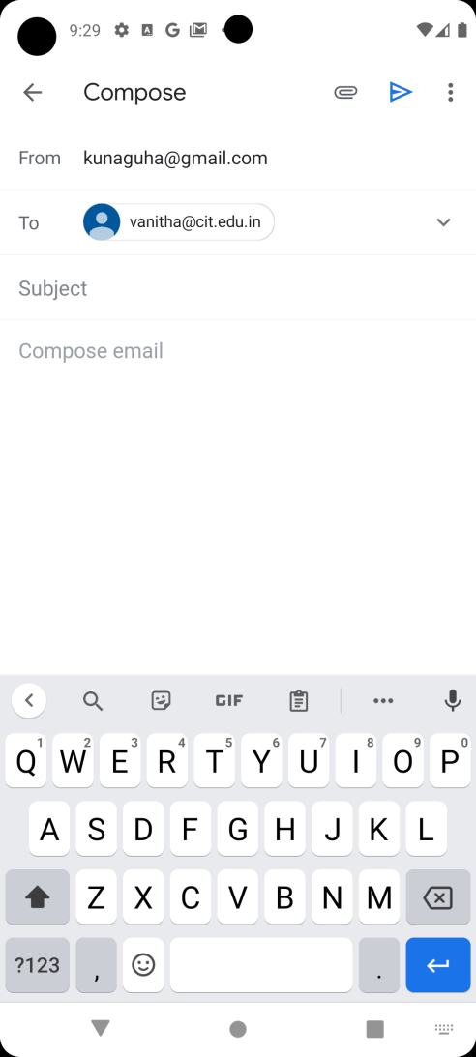

**Software Design Phase for "CIT Departmental Connect"**

During the software design phase, we create detailed diagrams to visually represent the system's architecture and workflows. Two key types of diagrams used in this phase are Data Flow Diagrams (DFDs) and Unified Modelling Language (UML) diagrams. Below are examples of each, focusing on the key functionalities of the "CIT Departmental Connect" application.

**Data Flow Diagram (DFD):**

A Data Flow Diagram (DFD) is used to represent the flow of information within the system. It helps in understanding how data moves through the system and how it is processed. Here, we provide a Level 0 DFD and a Level 1 DFD for user authentication and access to departmental information.

**Level 0 DFD**:

This diagram provides an overview of the system, showing the interactions between the main entities (users) and the system.

**Entities and Processes:**

* Users (Students, Faculty, Department Heads)
* CIT Departmental Connect System
* Authentication
* Access to Departmental Information
* Messaging
* Notes and Reminders

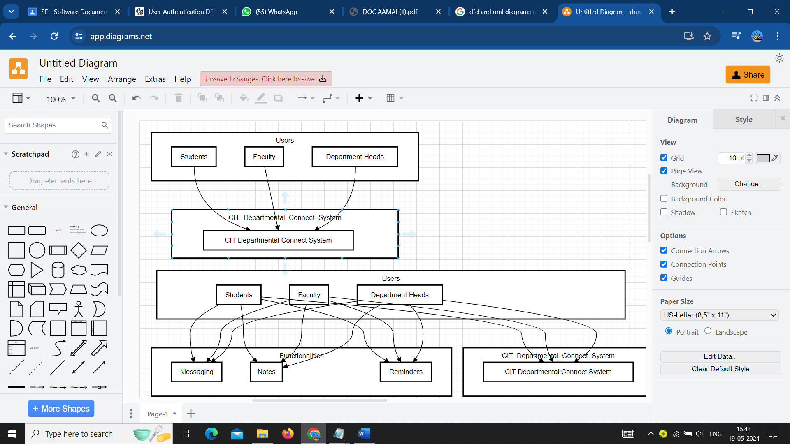

**Level 1 DFD**:

This diagram provides more detail about the user authentication process and how users access departmental information.

**Processes:**

* User Authentication
* Users provide credentials
* System verifies credentials via Firebase
* Access Departmental Information
* Authenticated users request information
* System retrieves and displays information

**Data Stores:**

* User Credentials (Firebase)
* Departmental Information Database

**Data Flows:**

* User credentials input
* Authentication request and response
* Information request and delivery

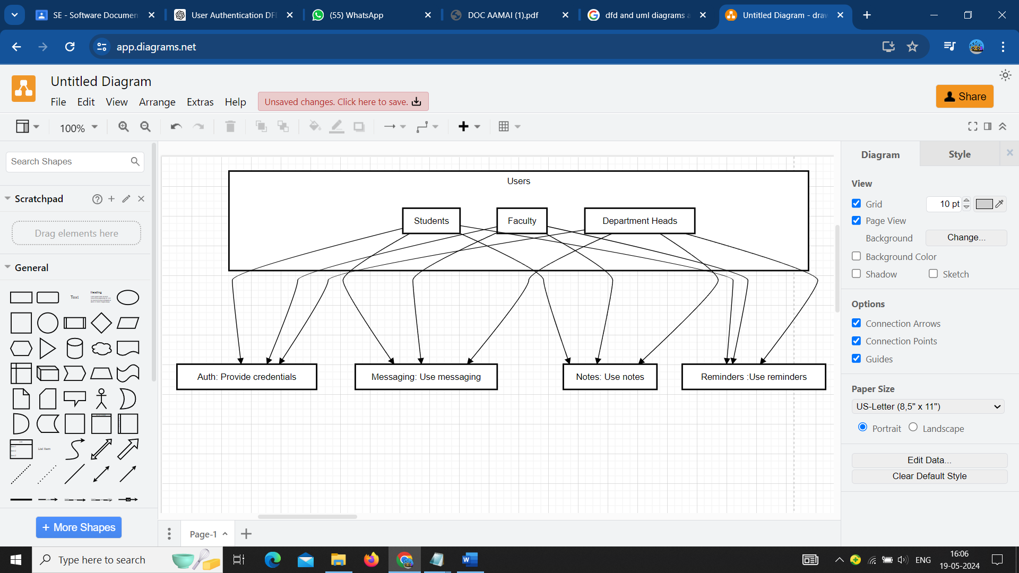

**Unified Modelling Language (UML) Diagrams:**

UML diagrams are used to visualize the design of a system. We will create a Use Case Diagram and a Class Diagram for key functionalities of the "CIT Departmental Connect" application.

**Use Case Diagram**

The Use Case Diagram illustrates the interactions between users and the system, detailing the primary functions.

**Actors:**

* Students
* Faculty
* Department Heads

**Use Cases:**

* Authenticate User
* View Departmental Information
* Send Messages
* Post Notes and Reminders
* Set Custom Reminders

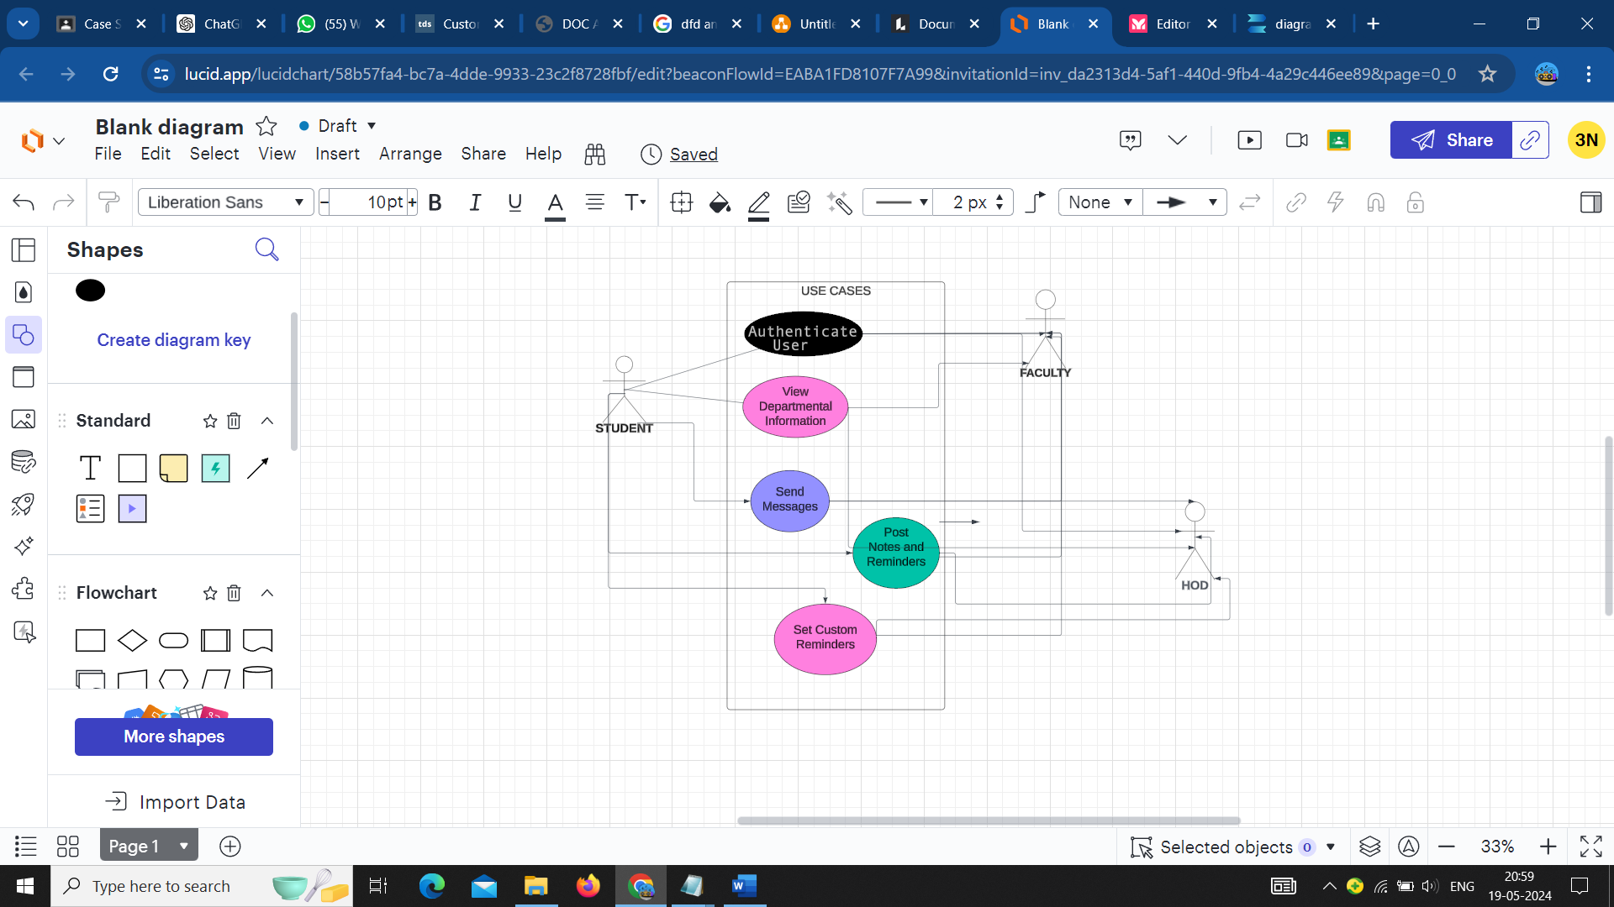

**Class Diagram**

The Class Diagram provides a detailed view of the system’s classes, their attributes, methods, and the relationships between them.

**Classes:**

User

* Attributes: userID, name, email, role
* Methods: authenticate(), viewInformation()

Department

* Attributes: departmentID, name, facultyList
* Methods: getInformation()

Message

* Attributes: messageID, sender, receiver, content, timestamp
* Methods: sendMessage(), receiveMessage()

Notes

* Attributes: noteID, author, content, timestamp
* Methods: postNote(), getNotes()

Reminder

* Attributes: reminderID, userID, content, dueDate
* Methods: setReminder(), getReminders()

**Relationships:**

* User "has" Department
* User "sends" Message
* User "posts" Note
* User "sets" Reminder

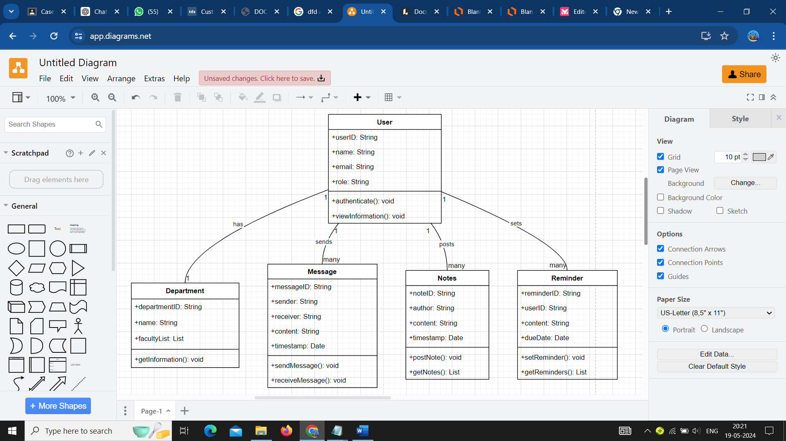

These diagrams provide a clear and structured visualization of the system, aiding in the understanding and development of the "CIT Departmental Connect" application. They serve as a blueprint for developers, ensuring that all functionalities are comprehensively covered and integrated effectively.

**Testing Phase for "CIT Departmental Connect"**

In the testing phase of the "CIT Departmental Connect" project, several aspects are evaluated to ensure the application's functionality, reliability, and usability. This phase encompasses the level of test automation, interactive testing, interactive debugging, and overall test coverage.

**Test Automation**

**Level of Test Automation:** The testing strategy incorporates various levels of automation to ensure efficient and thorough testing. Automated unit tests are developed using tools like Jest and JUnit to validate individual components and critical functionalities such as user authentication and data retrieval. Integration testing is automated using tools like Selenium or Cypress to verify seamless interaction between different modules and services. Continuous integration and continuous deployment (CI/CD) pipelines are established to integrate automated tests, ensuring that code changes are continuously tested before deployment to production.

**Interactive Testing**

**Interactive Testing Tools and Techniques:** In addition to automated tests, interactive testing techniques are employed to simulate real-world user interactions and gather feedback. Manual exploratory testing is conducted to uncover usability issues and unexpected behaviour. User acceptance testing (UAT) sessions involve stakeholders using the application as end-users to provide feedback on functionality and usability. Interactive testing tools such as Postman for API testing and mobile testing platforms like Browser Stack facilitate interactive testing across different devices and environments.

**Interactive Debugging**

**Interactive Debugging Techniques:** Robust debugging techniques are employed to diagnose and resolve issues efficiently. Developers utilize integrated development environments (IDEs) like Visual Studio Code and Android Studio, which offer advanced debugging capabilities such as breakpoints and variable inspection. Remote debugging tools enable live debugging sessions to troubleshoot issues occurring in production or on specific devices. These interactive debugging techniques ensure timely issue resolution and maintain application stability.

**Test Coverage**

**Ensuring Appropriate Level of Test Coverage:** Comprehensive test coverage is essential to validate all critical functionalities and user flows. Code coverage metrics are measured using tools like Istanbul and JaCoCo to ensure a high percentage of code coverage in unit and integration tests. Functional coverage is emphasized to ensure that all critical functionalities, user flows, and edge cases are thoroughly tested. Additionally, performance testing and security testing are conducted to ensure the application can handle expected loads and identify vulnerabilities.

**Summary**

The testing phase for "CIT Departmental Connect" employs a balanced approach of automated and interactive testing, along with robust debugging practices, to ensure a high-quality, reliable, and user-friendly application for the CIT community. By incorporating these strategies, the testing phase aims to validate the application's functionality, usability, and performance, ultimately delivering a seamless experience for users.

**Implementation Phase for "CIT Departmental Connect" Android App**

In the implementation phase of the "CIT Departmental Connect" Android app using Android Studio and Firebase, the focus is on building functional software components tailored for the Android platform. Below are the key steps and activities involved in this phase:

**Project Setup and Configuration**

**Setting Up Android Studio:** The implementation begins by setting up Android Studio, the official Integrated Development Environment (IDE) for Android app development. Developers configure the project settings, including package name, minimum SDK version, and dependencies required for Firebase integration.

**Frontend Development with Java**

**Java Development:** Frontend development involves creating the user interface and client-side functionalities using Java, the traditional programming language for Android development. XML layouts are used to design the app screens, while Java is used to add logic and interactivity to the UI elements. Android SDK components like Activities, Fragments, and Views are utilized to build the app's user interface and handle user interactions.

**Firebase Integration**

**Firebase Integration:** Firebase is integrated into the app to leverage its suite of services for authentication, database, cloud messaging, and analytics. Firebase Authentication is used to implement user authentication, allowing users to sign in securely using email/password or social media accounts. Firebase Realtime Database or Cloud Firestore is used as the backend database to store and retrieve app data. Firebase Cloud Messaging is utilized for push notifications, keeping users informed about important updates and announcements.

**Testing and Quality Assurance**

**Testing and Quality Assurance:** The app undergoes rigorous testing to ensure its reliability, functionality, and usability. Unit tests and instrumentation tests are written using frameworks like JUnit and Espresso to verify the correctness of individual components and UI interactions. Manual testing is conducted to simulate real-world usage scenarios and identify any issues that automated tests may have missed.

**Deployment to Google Play Store**

**Deployment to Google Play Store:** Once development and testing are complete, the app is prepared for deployment to the Google Play Store. Developers generate a signed APK or Android App Bundle (AAB) and upload it to the Play Console. App metadata, screenshots, and promotional materials are added to create an appealing listing on the Play Store. The app undergoes review by Google before it is published to the store for users to download and install.

**Maintenance & Support for "CIT Departmental Connect" Android App**

Maintaining and supporting the "CIT Departmental Connect" Android app is crucial to ensure its continued functionality, security, and usability. This phase involves ongoing efforts to address issues, update features, and provide assistance to users. Below are the key aspects of maintenance and support:

**Bug Fixes and Issue Resolution:**

**Bug Fixes:** Regular monitoring and user feedback collection help identify bugs and issues within the app. A dedicated team of developers promptly investigates reported issues and releases bug fixes as necessary. Continuous integration and continuous deployment (CI/CD) pipelines are utilized to streamline the process of deploying bug fixes to production.

**Feature Updates and Enhancements:**

**Feature Updates:** As user needs evolve and technology advances, new features and enhancements are developed to improve the app's functionality and user experience. Feedback from users and stakeholders is gathered to prioritize feature requests and guide the development roadmap. Agile development methodologies are employed to iteratively release updates and incorporate new features into the app.

**Security Maintenance**

**Security Patches:** Ensuring the security of the app is paramount to protect user data and maintain trust. Regular security audits are conducted to identify vulnerabilities and weaknesses in the app's code and infrastructure. Security patches and updates are promptly deployed to address any identified security risks. Firebase's built-in security features, such as Firebase Authentication and Cloud Fire store security rules, are utilized to enhance data security.

**Performance Optimization**

**Performance Monitoring:** Monitoring app performance is essential to identify and address performance issues that may arise over time. Performance metrics such as app start-up time, response time, and resource utilization are continuously monitored. Optimization techniques such as code refactoring, database indexing, and network optimization are applied to improve app performance and responsiveness.

**User Support and Assistance**

**User Assistance:** Providing prompt and effective user support is essential to address user inquiries, troubleshoot issues, and assist with app usage. A dedicated support team responds to user queries and provides assistance via various channels such as email, in-app chat support, or a dedicated support portal. Frequently asked questions (FAQs) and knowledge base articles are maintained to address common user concerns and provide self-service support options.

**CONCLUSION:**

"CIT Departmental Connect" serves as more than just a mobile application; it symbolizes a commitment to innovation, collaboration, and excellence within the academic community. By empowering users with easy access to information, seamless communication channels, and enhanced security measures, the app fosters a conducive environment for learning, research, and professional growth at CIT. It represents a significant step towards digital transformation and sets a precedent for leveraging technology to enrich the educational experience and strengthen community bonds.